

JAVA PROJECT REPORT ON
Electronic Store Product Catalog and Sales Management System

Submitted by
MAHALAKSHMI M
25BIT030

Under the Guidance of
DHILEEBAN A
Technical Trainer
Technical Department, KG College of Arts and Science

Academic Year: 2025 – 2026
APRIL 2026
Semester: I

DECLARATION
I hereby declare that the project entitled “Electronic Store Product Catalog and Sales Management System” submitted in partial fulfillment of the requirements for the course I B.SC IT-A is a record of my original work carried out under the guidance of DHILEEBAN A , Technical Trainer, Technical Department, KG College of Arts and Science.
I further declare that this project has not been submitted previously, either in part or in full, for the award of any degree, diploma, or other similar title, at this or any other institution.
I have acknowledged all sources of information used in this project wherever applicable.

April 2026
Coimbatore

________________________
(Your Name)

CERTIFICATE
This is to certify that the project entitled “Electronic Store Product Catalog and Sales Management System” is a bona fide work carried out by [MAHALAKSHMI M], [I B.SC IT -A], KG College of Arts & Science, in partial fulfillment of the requirements for the course [Course Name].
This project has been completed under my supervision and guidance during the academic period April 2026.

Place:
Date:

Submitted for the Viva-Voce Examination held on __________________________________

Guide: Head of the Department
(Technical Trainer, KGCAS) (Technical Head, KGCAS)

______________________ _______________________

TABLE OF CONTENTS
S. No. | Topics | Page. No.
1 | Introduction
1.1 | Objective
1.2 | Overview
1.3 | Features
2 | Program Analysis
2.1 | Problem Definition
2.2 | Project Overview
2.3 | Scopes and Limitations
3 | System Design
3.1 | Modules
4 | Methodology
4.1 | Problem Analysis
4.2 | System Design
4.3 | Program Development
4.4 | Testing and Validation
4.5 | Result and Documentation
4.6 | Algorithm
4.7 | Flowchart
5 | Source Code
6 | Input and Output Screens
7 | Discussion and Conclusion
7.1 | Discussion
7.2 | Conclusion
8 | References

ABSTRACT

The Electronic Store Product Catalog and Sales Management System is a software-based solution developed to automate and streamline the daily operations of an electronic retail store. In traditional systems, product records and sales transactions are managed manually, which often results in human errors, data inconsistency, and time consumption. This project aims to overcome these limitations by providing an efficient and reliable digital system.
The proposed system focuses on managing product information, including Product ID, Name, Price, and Quantity, in a structured manner. It enables users to perform essential operations such as adding new products, updating existing records, deleting products, and viewing product details. In addition, the system incorporates a sales management module, which allows users to process transactions, generate bills, and automatically update the inventory stock after each sale.
This application is developed using the Java programming language and follows Object-Oriented Programming (OOP) principles such as encapsulation, modularity, and reusability, ensuring better code organization and maintainability. The system is designed as a menu-driven console application, making it user-friendly, simple to operate, and suitable for beginners as well as small-scale businesses.
The implementation of this system significantly improves accuracy, reduces manual workload, and enhances overall operational efficiency. Although the current version is limited to a basic console interface without database support, it provides a strong foundation for future enhancements such as Graphical User Interface (GUI) integration and database connectivity for large-scale applications.

- INTRODUCTION
In today’s fast-growing digital world, the use of software applications has become essential in managing business operations efficiently. Electronic stores deal with a large number of products, customer transactions, and inventory updates on a daily basis. Handling these activities manually can lead to errors, data loss, and inefficiency, making it difficult to maintain accurate records.
The Electronic Store Product Catalog and Sales Management System is designed to provide an automated solution for managing store operations effectively. This system helps in organizing product information such as Product ID, Name, Price, and Quantity, and allows users to perform operations like adding, updating, deleting, and viewing products easily.
One of the major advantages of this system is the integration of a sales management module, which enables the user to process transactions and generate bills automatically. It also updates the inventory stock in real-time after each sale, ensuring that the product availability is always accurate.
The system is developed using the Java programming language and follows Object-Oriented Programming (OOP) concepts such as encapsulation, inheritance, and modularity. These concepts improve the structure, reusability, and maintainability of the program. The application is implemented as a menu-driven console system, which makes it simple, interactive, and easy to use.
This project is especially useful for small-scale electronic stores, where managing data manually is time-consuming and prone to mistakes. By using this system, store owners can achieve better accuracy, efficiency, and productivity in their daily operations.
In conclusion, the proposed system replaces the traditional manual process with a reliable, fast, and user-friendly digital solution, making store management more effective and organized.

1.1 Objective
The main objective of the Electronic Store Product Catalog and Sales Management System is to develop a reliable and efficient software solution that simplifies the management of store operations. The system aims to replace manual processes with an automated approach to improve overall performance.
The specific objectives of the system are:
- To design a system for managing product details in an organized manner
- To automate the sales and billing process for faster transactions
- To maintain accurate inventory records and update stock in real-time
- To reduce human errors in data entry and calculations
- To improve efficiency, productivity, and data accuracy
- To provide a user-friendly interface for easy interaction
By achieving these objectives, the system ensures smooth and effective store management

1.2 Overview
The Electronic Store Product Catalog and Sales Management System is a menu-driven console application developed using the Java programming language. It is designed to perform all essential operations required for managing an electronic store in a simple and efficient way.
The system allows users to perform various functions such as adding new products, viewing product details, updating existing records, deleting products, and processing sales transactions. All product-related data is stored using dynamic data structures like ArrayList, which allows flexible and efficient data handling.
The application is based on Object-Oriented Programming (OOP) concepts such as classes, objects, and methods, ensuring modularity and easy maintenance. Each operation is implemented as a separate function, making the system well-structured and easy to understand.
Overall, the system provides a complete solution for managing product catalogs and sales operations in a simple and effective manner.

1.3 Features
The Electronic Store Product Catalog and Sales Management System includes several important features that enhance its functionality and usability:
- Product Management:
Allows users to add, update, delete, and view product details efficiently
- Inventory Tracking:
Automatically updates stock levels after each sales transaction
- Sales Processing:
Enables quick and accurate billing, calculating the total amount based on product price and quantity
- User-Friendly Interface:
Provides a simple menu-driven system that is easy to use for all users
- Error Reduction:
Minimizes manual errors in calculations and data entry
- Efficient Data Handling:
Uses dynamic data structures for storing and managing data effectively
- Scalability:
The system can be enhanced by adding database integration, GUI, and advanced features

- PROGRAM ANALYSIS
Program Analysis is an important phase in software development where the existing system is studied, problems are identified, and requirements for the new system are analyzed. It helps in understanding the need for automation and ensures that the developed system meets user requirements effectively.
In the case of the Electronic Store Product Catalog and Sales Management System, program analysis focuses on identifying the issues in manual store management and designing a solution to improve accuracy, efficiency, and data management. This phase involves understanding the workflow of the store, identifying limitations, and defining the scope of the system.

2.1 Problem Definition
In many electronic stores, operations such as maintaining product records, tracking inventory, and processing sales are handled manually. This leads to several problems, including:
- Human errors in billing and calculations
- Difficulty in maintaining accurate inventory records
- Time-consuming manual data entry and record keeping
- Lack of proper data organization and retrieval
- Increased chances of data loss or duplication
Due to these issues, store management becomes inefficient and unreliable. Therefore, there is a need for a computerized system that can automate these processes and provide a fast, accurate, and reliable solution.
The proposed system addresses these problems by providing an automated platform for managing products, sales, and inventory.

2.2 Project Overview
The Electronic Store Product Catalog and Sales Management System is designed as a complete solution for managing store operations efficiently. It integrates different functionalities into a single application, making it easier for users to handle all tasks.
The system includes the following major functions:
- Product Management: Adding, updating, deleting, and viewing products
- Inventory Management: Tracking and updating stock levels
- Sales Processing: Generating bills and calculating total amount
The system is implemented using Java programming language and follows Object-Oriented Programming (OOP) concepts such as encapsulation, modularity, and reusability. It uses ArrayList for storing product data dynamically.
The application is designed as a menu-driven console program, allowing users to interact with the system easily. It ensures that all operations are performed efficiently and accurately.

2.3 Scopes and Limitations
Scope:
The scope of the system defines the extent to which the application can be used. The key scope includes:
- Suitable for small and medium-scale electronic stores
- Provides efficient product and sales management
- Reduces manual workload and improves productivity
- Ensures accurate inventory tracking
- Can be extended with additional features such as database integration and graphical user interface (GUI)

Limitations:
Despite its advantages, the system has some limitations:
- Data is not stored permanently as there is no database support
- The system uses a console-based interface, which may not be visually attractive
- Limited to basic functionalities without advanced reporting features
- Not suitable for large-scale enterprises without further enhancements

- SYSTEM DESIGN
System Design is an important phase in software development that defines the structure, components, and working process of the system. It provides a clear plan for how the system will function and how different modules will interact with each other.
The Electronic Store Product Catalog and Sales Management System is designed using a modular and object-oriented approach. This approach divides the system into smaller parts, making it easier to develop, understand, and maintain. Each part of the system performs a specific function, ensuring efficiency and flexibility.
The system is developed using Java programming language and follows Object-Oriented Programming (OOP) concepts such as:
- Encapsulation – combining data and methods into a single unit
- Modularity – dividing the system into separate modules
- Reusability – using existing code for multiple purposes
The system uses a menu-driven console interface, where users interact with the application by selecting options. Based on the selected option, the corresponding operation is performed

3.1 Modules
The system is divided into different modules, each responsible for performing a specific function. This modular design improves clarity, efficiency, and maintainability of the system.
1. Product Management Module
This module handles all operations related to product details. It allows the user to:
- Add new products with ID, Name, Price, and Quantity
- Update existing product information
- Delete product records
- View all available products
This module ensures proper organization of product data

2. Inventory Management Module
The Inventory Management Module is responsible for maintaining the stock levels of products.
- Updates product quantity after each sale
- Prevents selling of out-of-stock items
- Helps in tracking product availability
This module ensures accurate and real-time inventory control.

3. Sales Management Module
This module manages all sales transactions in the system.
- Allows users to select products and enter quantity
- Calculates the total bill amount
- Displays transaction details
- Updates stock after purchase
It helps in performing fast and accurate billing operations.

4. User Interface Module
This module provides a menu-driven interface for interaction.
- Displays options to the user
- Accepts user input
- Redirects to appropriate modules
It ensures the system is easy to use and user-friendly.

5. Data Handling Module
This module is responsible for managing data storage and retrieval.
- Uses Array List to store product objects
- Allows efficient searching and updating of records
- Ensures smooth data operations

- METHODOLOGY
Methodology describes the step-by-step process followed in developing the Electronic Store Product Catalog and Sales Management System. It explains how the problem is analyzed, designed, implemented, tested, and documented systematically.
The development of this system follows a structured approach to ensure accuracy, efficiency, and successful implementation

4.1. Problem Analysis
In this phase, the existing system is studied to identify the problems and limitations. Most electronic stores manage their data manually, which leads to:
- Errors in billing and calculations
- Difficulty in maintaining inventory records
- Time-consuming operations
- Poor data management
After analyzing these issues, it is clear that an automated system is required to improve efficiency and accuracy.

4.2. System Design
In this phase, the structure of the system is planned. The system is divided into modules such as:
- Product Management
- Inventory Management
- Sales Management
The system is designed using Object-Oriented Programming (OOP) concepts. Data is stored using ArrayList, and a menu-driven interface is used for user interaction.

4.3. Program Development
In this phase, the actual coding of the system is done using Java programming language.
- Classes and objects are created
- Methods are implemented for each operation
- User input is handled using Scanner class
- Logic is written for adding, updating, deleting, and billing
The program is developed in a modular and structured manner.
.
4.4. Testing and Validation
After development, the system is tested to ensure it works correctly.
- Unit Testing: Each module is tested separately
- Integration Testing: All modules are tested together
- Validation: Ensures correct output for given input
Errors are identified and corrected to ensure the system is bug-free and reliable

4.5. Result and Documentation
The final system is executed and results are verified.
- The system successfully performs all operations
- Output is accurate and efficient
- Proper documentation is prepared for understanding
Documentation includes design, code, outputs, and explanations.

4.6. Algorithm

- Start
- Display menu options
- Read user choice
- If choice = Add Product
→ Enter product details
→ Store in ArrayList
- If choice = View Products
→ Display all products
- If choice = Update Product
→ Search product by ID
→ Modify details
- If choice = Delete Product
→ Remove product from list
- If choice = Billing
→ Enter product ID and quantity
→ Calculate total amount
→ Update stock
- Repeat until user selects Exit
- Stop

4.7. Flowchart

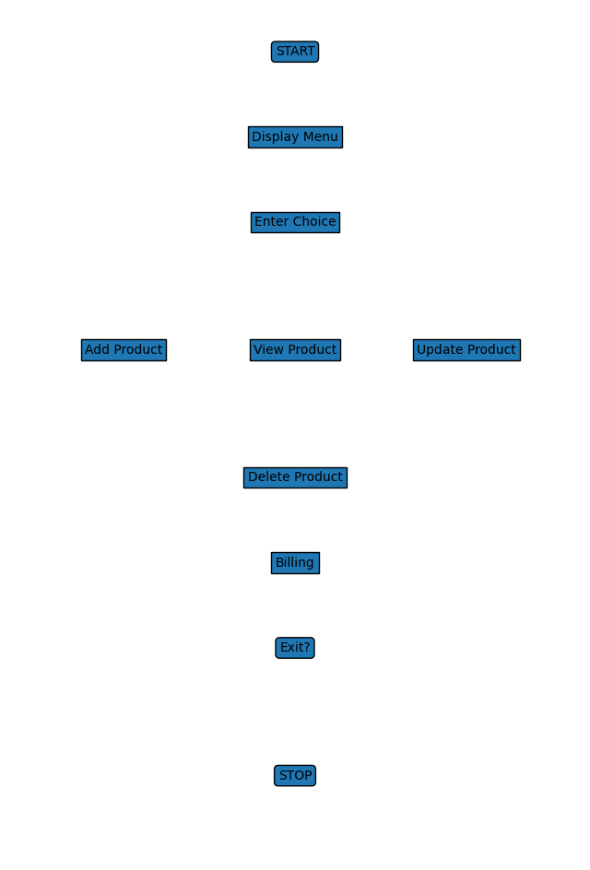

- SOURCE CODE

import java.util.ArrayList;
import java.util.Scanner;
// Product Class
class Product {
int id;
String name;
double price;
int quantity;

Product(int id, String name, double price, int quantity) {
this.id = id;
this.name = name;
this.price = price;
this.quantity = quantity;
}
}

// Main Class
public class ElectronicStore {

static ArrayList<Product> productList = new ArrayList<>();
static Scanner sc = new Scanner(System.in);

// Add Product
public static void addProduct() {
System.out.print("Enter Product ID: ");
int id = sc.nextInt();
sc.nextLine();

System.out.print("Enter Product Name: ");
String name = sc.nextLine();

System.out.print("Enter Price: ");
double price = sc.nextDouble();

System.out.print("Enter Quantity: ");
int quantity = sc.nextInt();

productList.add(new Product(id, name, price, quantity));
System.out.println("Product Added Successfully!");
}

// View Products
public static void viewProducts() {
if (productList.isEmpty()) {
System.out.println("No Products Available!");
return;
}

System.out.println("\n--- Product List ---");
for (Product p : productList) {
System.out.println("ID: " + p.id +
", Name: " + p.name +
", Price: " + p.price +
", Quantity: " + p.quantity);
}
}

// Update Product
public static void updateProduct() {
System.out.print("Enter Product ID to Update: ");
int id = sc.nextInt();

for (Product p : productList) {
if (p.id == id) {
sc.nextLine();
System.out.print("Enter New Name: ");
p.name = sc.nextLine();

System.out.print("Enter New Price: ");
p.price = sc.nextDouble();

System.out.print("Enter New Quantity: ");
p.quantity = sc.nextInt();

System.out.println("Product Updated Successfully!");
return;
}
}
System.out.println("Product Not Found!");
}

// Delete Product
public static void deleteProduct() {
System.out.print("Enter Product ID to Delete: ");
int id = sc.nextInt();

for (Product p : productList) {
if (p.id == id) {
productList.remove(p);
System.out.println("Product Deleted Successfully!");
return;
}
}
System.out.println("Product Not Found!");
}

// Billing
public static void billing() {
System.out.print("Enter Product ID: ");
int id = sc.nextInt();

for (Product p : productList) {
if (p.id == id) {
System.out.print("Enter Quantity: ");
int qty = sc.nextInt();

if (qty <= p.quantity) {
double total = qty * p.price;
p.quantity -= qty;

System.out.println("Total Bill: " + total);
System.out.println("Transaction Successful!");
} else {
System.out.println("Insufficient Stock!");
}
return;
}
}
System.out.println("Product Not Found!");
}

// Main Method
public static void main(String[] args) {

int choice;

do {
System.out.println("\n===== Electronic Store Menu =====");
System.out.println("1. Add Product");
System.out.println("2. View Products");
System.out.println("3. Update Product");
System.out.println("4. Delete Product");
System.out.println("5. Billing");
System.out.println("6. Exit");
System.out.print("Enter your choice: ");

choice = sc.nextInt();

switch (choice) {
case 1:
addProduct();
break;
case 2:
viewProducts();
break;
case 3:
updateProduct();
break;
case 4:
deleteProduct();
break;
case 5:
billing();
break;
case 6:
System.out.println("Exiting...");
break;
default:
System.out.println("Invalid Choice!");
}

} while (choice != 6);
}
}

- INPUT AND OUTPUT SCREENS

* Main Menu Screen

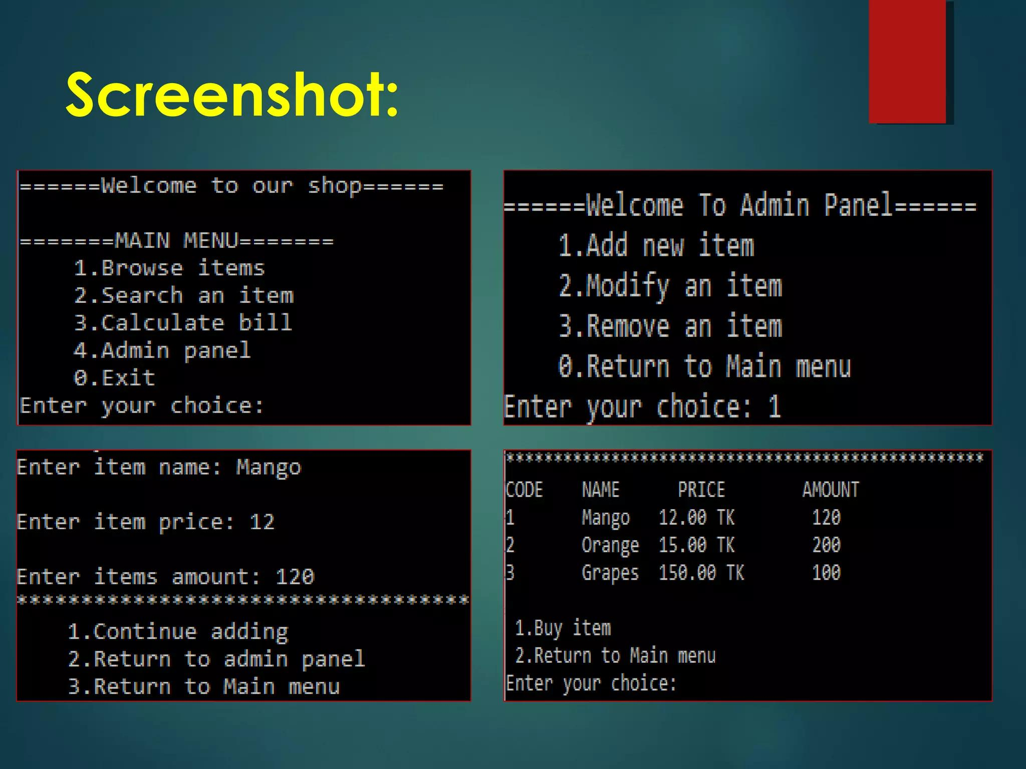

- DISCUSSION & CONCLUSION

7.1 Discussion
The Electronic Store Product Catalog and Sales Management System improves store operations by using automation instead of manual work. It efficiently manages product details, inventory, and sales transactions. The system reduces human errors and provides accurate billing through automatic calculations.
The use of Java and OOP concepts makes the system modular and easy to maintain. However, it is limited by its console-based interface and lack of database storage. Overall, the system is useful for small-scale store management and can be improved with advanced features.

7.2 Conclusion
The system successfully achieves its goal of providing an efficient and reliable solution for managing electronic store operations. It simplifies tasks like product management, billing, and inventory tracking.
By using automation, the system improves accuracy, speed, and productivity. Although it has some limitations, it can be enhanced with GUI and database integration in the future. Overall, it is a useful and practical application for store management.

- REFERENCES

Herbert Schildt, Java: The Complete Reference, McGraw-Hill Education.
- E. Balagurusamy, Programming with Java, McGraw-Hill Education.
- Oracle Corporation, Java Documentation,
Available at: https://docs.oracle.com/javase
- GeeksforGeeks, Java Programming Tutorials,
Available at: https://www.geeksforgeeks.org
- W3Schools, Java Tutorial,
Available at: https://www.w3schools.com/java
- Study materials and class notes provided by course instructor

